Student’s Name: Kibet Brian
Admission Number: 190814
Lecturer’s Name: Mr. Talo Harrison
Course Unit: MST 8303 Penetration Testing, PT
Course Code: MST 8303
DDoS Attack Using HOIC
Date: June 29th, 2025
DDoS Attack Using HOIC
Kali IP address: 10.9.51.48
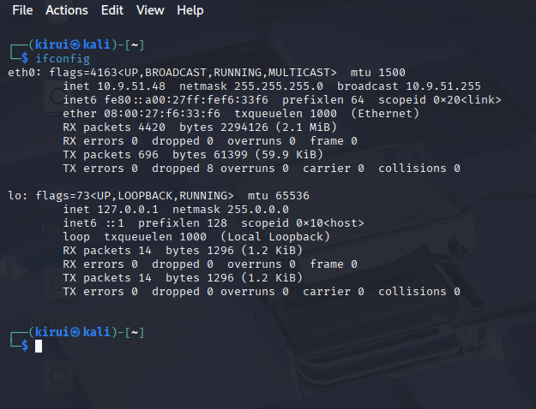

Windows Server 2016: 10.9.51.37
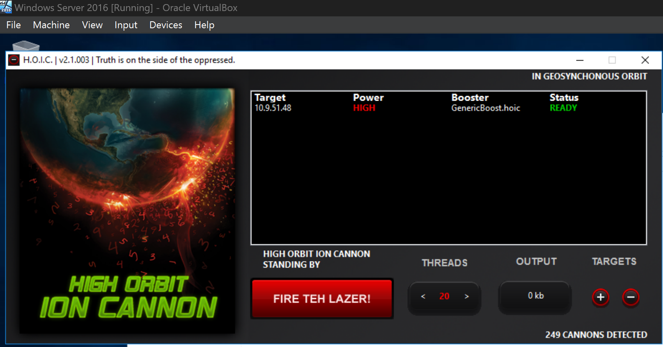

Windows 10: 10.9.51.38
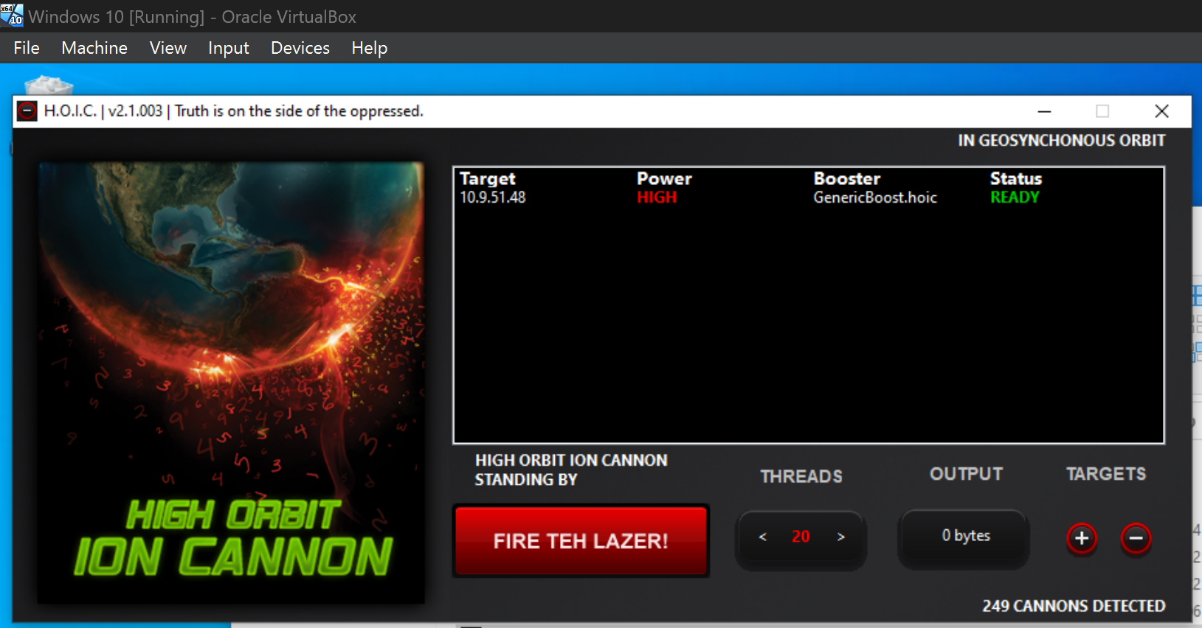

Windows 7: 10.9.51.33
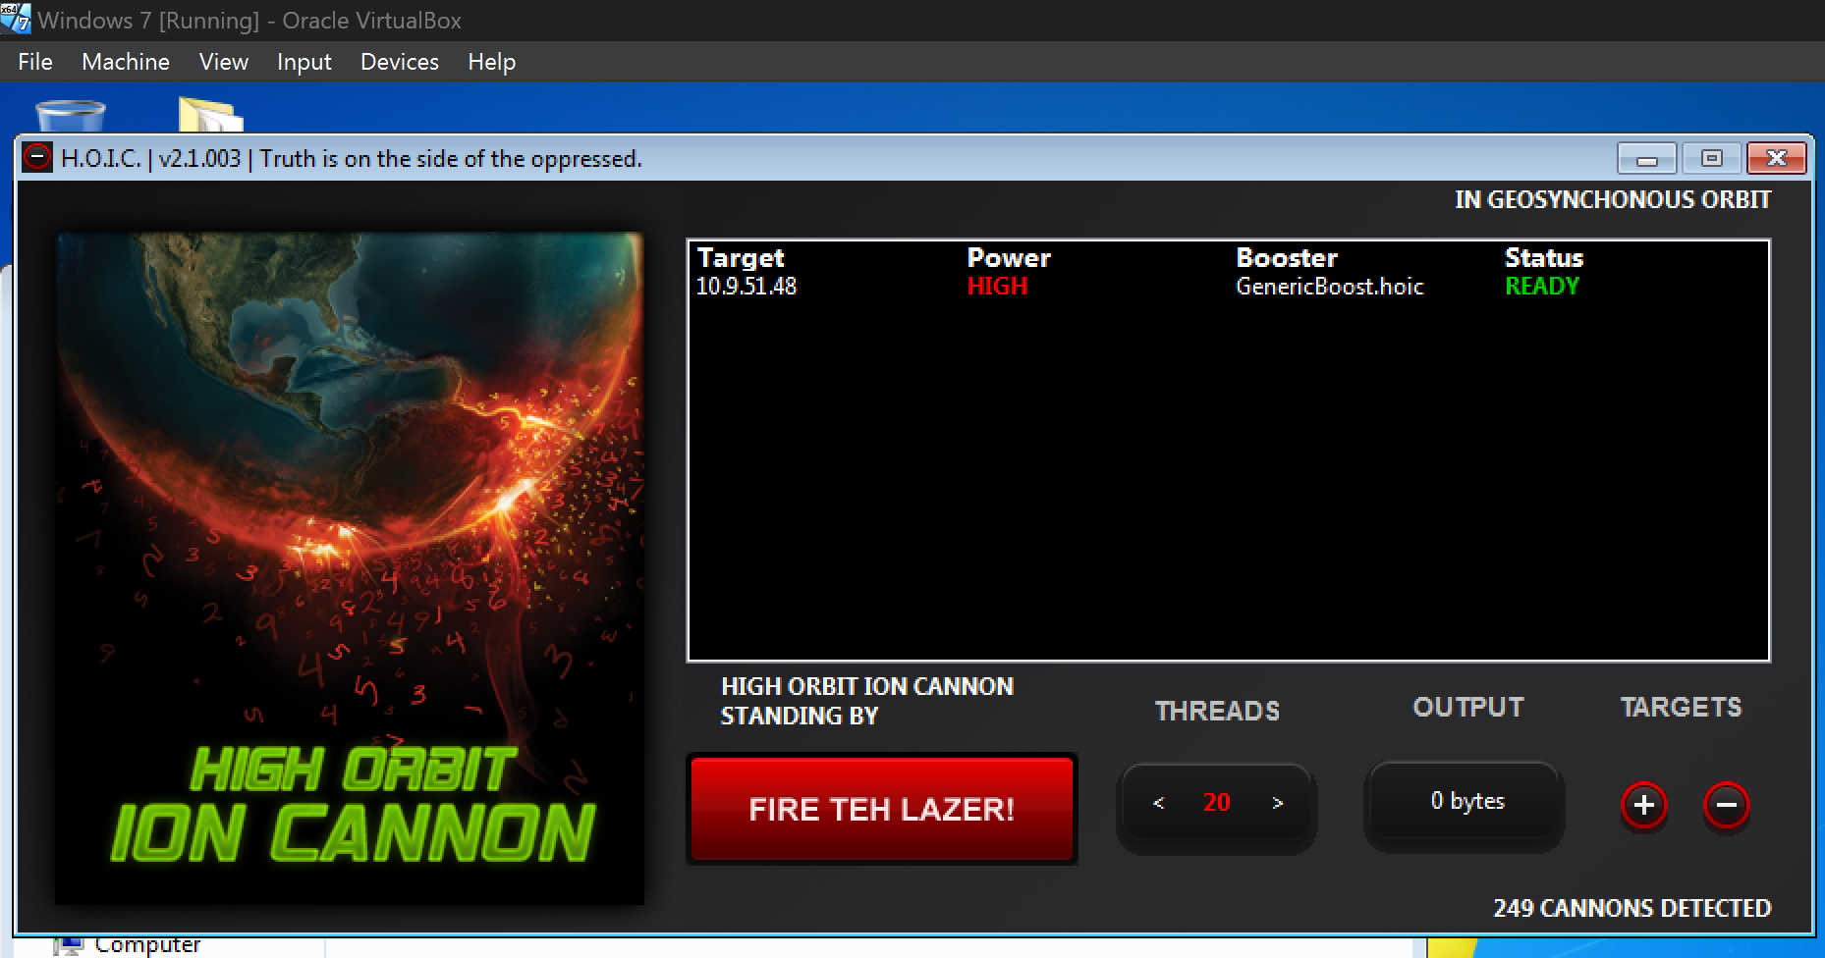

Wireshark on Kali Linux:
